**UNIT 1 : TYPES OF PLANNING**

**PART 1**

Business planning seems like it would be something that organizations do well, given the near self-evident importance of the concept. Yet, that is not necessarily the case. “In my experience leading dozens of business planning workshops in countries all over the world, I’d say [only about 10% to 15%](https://www.entrepreneur.com/article/219424) of teams I’ve encountered have an effective business planning process,” according to author and business plan expert Tim Berry in *Entrepreneur*.

Organizations should develop a better understanding of how to approach business planning. The following sections expand on the topic and the four types of planning.

**Why Plan?**

“Planning is about managing resources and priorities in an organized way,” Berry says. “Management is related to leadership, and it’s related to productivity.”

If companies improve how they plan, managing and leadership will also improve. The following steps can help businesses plan better.

* **Devise a Plan**: Write important details down and focus on strengths, what matters, what people are most important to you and what you can do for them. This will help you communicate your vision to your employees.
* **Define Success**: How do you see your business in several years? Define long-term goals and be specific. Establish milestones for certain goals and who will achieve the goals. Look at what drives your business; it may be presentations, conversions, page views or something else. Then establish a review schedule and re-examine your long-term goals as necessary.
* **Put It in Motion**: Track and analyze numbers to help you manage the work behind the numbers. You’ll be better able to make changes — or to develop new plans — that will help you manage better.

**The 4 Types of Plans**

**Operational Planning**

“Operational plans are about [how things need to happen](https://www.linkedin.com/pulse/3-major-types-plans-especially-lean-thinkers-mack-story),” motivational leadership speaker Mack Story said at LinkedIn. “Guidelines of how to accomplish the mission are set.”

This type of planning typically describes the day-to-day running of the company. Operational plans are often described as single use plans or ongoing plans. Single use plans are created for events and activities with a single occurrence (such as a single marketing campaign). Ongoing plans include policies for approaching problems, rules for specific regulations and procedures for a  step-by-step process for accomplishing particular objectives.

**Strategic Planning**

“Strategic plans are all about why things need to happen,” Story said. “It’s big picture, long-term thinking. It starts at the highest level with defining a mission and casting a vision.”

Strategic planning includes a high-level overview of the entire business. It’s the foundational basis of the organization and will dictate long-term decisions. The scope of strategic planning can be anywhere from the next two years to the next 10 years. Important components of a strategic plan are vision, mission and values.

**Tactical Planning**

“Tactical plans are about what is going to happen,” Story said. “Basically at the tactical level, there are many focused, specific, and short-term plans, where the actual work is being done, that support the high-level strategic plans.”

Tactical planning supports strategic planning. It includes tactics that the organization plans to use to achieve what’s outlined in the strategic plan. Often, the scope is less than one year and breaks down the strategic plan into actionable chunks. Tactical planning is different from operational planning in that tactical plans ask specific questions about what needs to happen to accomplish a strategic goal; operational plans ask how the organization will generally do something to accomplish the company’s mission.

**Contingency Planning**

Contingency plans are made when something unexpected happens or when something needs to be changed. Business experts sometimes refer to these plans as a special type of planning.

Contingency planning can be helpful in circumstances that call for a change. Although managers should anticipate changes when engaged in any of the primary types of planning, contingency planning is essential in moments when changes can’t be foreseen. As the business world becomes more complicated, contingency planning becomes more important to engage in and understand.

**PART 2**

Effective planning is the foundation of any successful business. Planning revolves around organizing priorities and resources and it relates to productivity. Since productivity levels directly affect the success of any organization it’s vital that businesses are creating plans that work. When there are issues with leadership there are often flaws in the company’s plan. When a company improves how they plan they can expect all other aspects of the business to improve as well.

The first step to improving a business plan is to make sure that specific issues are being dealt with directly within the plan. This means that there is a clear vision of what a successful execution will look like. Set goals and establish markers so that progress can be measured and necessary changes can be made accordingly to stay on track. Everyone involved should have a clear understanding of what the goals are before the plan is ever put in motion.

There are [four types of planning](https://study.com/academy/lesson/types-of-planning-strategic-tactical-operational-contingency-planning.html). Each type of plan commits employees within different departments and their resources to specific actions. While there are many different types, the four major types of plans include strategic, tactical, operational, and contingency.

Here is a break down of what each type of planning entails.

**Operational Plans**

Operational planning can be ongoing or single-use. The latter is usually created for a specific event that will only occur once, such as a unique marketing campaign. Ongoing plans can include rules and regulations, procedures, and the day to day running of the company.

**Strategic Plans**  
Strategic planning is the foundation of an organization. Essentially, strategic plans dictate the important decisions made within a business. Strategic plans can have scopes that range from three years to ten years. These plans include the organization’s mission, values, and vision. A good strategic plan always considers things in the long-term and remembers the big picture.

**Tactical Plans**

Tactical planning is supportive of the strategic plan. It involves the tactics that will be used to execute the strategic plan. Within a tactical plan, there are specific questions that need to be answered about what it will take to accomplish the goals set in the strategic plan; the most important question being how the company will accomplish the mission. This type of planning is very focused and short-term. Tactical plans are sometimes flexible and often break the strategy down into several parts and assign actionable tasks to each part.

**Contingency Plans**  
Contingency planning is important for any business because there is always the possibility of unforeseen changes. A contingency plan is created for when the unexpected occurs or a major change needs to be made in order to continue towards the goal. Not every change can be anticipated which is why it’s imperative to have a contingency plan in place. Every business leader should understand the importance of having a contingency plan.

A company whose leaders have a clear understanding of the different types of planning can expect to create a successful business that is sustainable.

#### ****PART 3****

#### ****Meaning of Planning:****

Planning is very important for successfulness and the effective performance of an organisation not only for organisations but also for individuals. It is the most basic of all the managerial functions. It involves selecting missions and objectives and the actions to achieve them. Therefore every organisation gives a greater emphasis on planning.

Planning as a process involves the determination of future course of action, that is why an action, what action, how to take action, and when to take action. These are related with different aspects of planning process.

Thus, Terry has defined planning in terms of future course of action i.e., “planning is the selection and relating of facts and making and using of assumptions regarding the future in the visualisation and formalisation of proposed activities believed necessary to achieve desired result.”

McFarland has defined Planning as **“a concept of executive action that embodies the skills of anticipating, influencing and controlling the nature and direction of change.”**

Peter Drucker defined as “planning is the continuous process of making present entrepreneurial decisions systematically and with best possible knowledge their futurity, organizing systematically the efforts needed to carry out these decisions and measuring the results of these decisions against the expectation through organised systematic feedback.”

In the words of Koontz and O’Donnell, **“planning is deciding in advance what to do, how to do it, when to do it, and who is to do it. Planning bridges the gap from where we are to here we want to go.”**

ADVERTISEMENTS:

According to Theo Haimann, “planning is the function that determines in advance what should be done. It consists of selecting the enterprise objectives polices, programmes, procedures and other means of achieving these objectives.”

#### Types of Planning:

**The process of planning may be classified into different categories on the following basis:**

**(i) Nature of Planning:**

a. Formal planning.

b. Informal planning.

**(ii) Duration of planning:**

a. Short term planning.

b. Long term planning.

**(iii) Levels of Management:**

a. Strategic planning.

b. Intermediate planning.

c. Operational planning.

**(iv) Use:**

a. Standing plans

b. Single-use plans.

**(i) Nature of Planning:**

**a. Formal Planning:**

Planning is formal when it is reduced to writing. When the numbers of actions are large it is good to have a formal plan since it will help adequate control.

The term formal means official and recognised. Any planning can be done officially to be followed or implemented. Formal planning is aims to determine and objectives of planning. It is the action that determine in advance what should be done.

**Advantages:**

1. Proper Cooperation among employees,

2. Unity of Action,

3. Economy,

4. Proper coordination and control,

5. Choosing the right objectives, and

6. Future plan.

**b. Informal Planning:**

An informal plan is one, which is not in writing, but it is conceived in the mind of the manager. Informal planning will be effective when the number of actions is less and actions have to be taken in short period.

**(ii) Duration of Planning:**

**a. Short term Planning:**

Short term planning is the planning which covers less than two years. It must be formulated in a manner consistent with long-term plans. It is considered as tactical planning. Short-term plans are concerned with immediate future; it takes into account the available resources only and is concerned with the current operations of the business.

These may include plans concerning inventory planning and control, employee training, work methods etc.

**Advantages:**

1. It can be easily adjustable.

2. Changes can be made and incorporated.

3. Easy to Gauge.

4. Only little resources required.

**Disadvantages:**

1. Very short period-left over things will be more.

2. Difficult to mobiles the resources.

3. Communication cycle will not be completed.

**b. Long-Term Planning:**

Long-term planning usually converse a period of more than five years, mostly between five and fifteen years. It deals with broader technological and competitive aspects of the organisation as well as allocation of resources over a relatively long time period. Long-term planning is considered as strategic planning.

Short-term planning covers the period of one year while long term planning covers 5-15 years. In between there may be medium-term plans. Usually, medium term plans are focusing on between two and five years. These may include plan for purchase of materials, production, labour, overhead expenses and so on.

**Advantages:**

1. Sufficient time to plan and implement.

2. Effective control.

3. Adjustment and changes may be made gradually.

4. Periodic evaluation is possible.

5. Thrust areas can be identified easily.

6. Weakness can be spotted and rectified then and there.

**Disadvantages:**

1. Prediction is difficult.

2. Full of uncertainties.

3. Objectives and Targets may not be achieved in full.

4. More resources required.

**(iii) Levels of Management:**

**a. Strategic Planning:**

The strategic planning is the process of determining overall objectives of the organisation and the policies and strategies adopted to achieve those objective. It is conducted by the top management, which include chief executive officer, president, vice-presidents, General Manger etc. It is a long range planning and may cover a time period of up to 10 years.

It basically deals with the total assessment of the organisation’s capabilities, its strengths and its weaknesses and an objective evaluation of the dynamic environment. The planning also determines the direction the company will be taking in achieving these goals.

**b. Intermediate Planning:**

Intermediate planning cover time frames of about 6 months to 2 years and is contemplated by middle management, which includes functional managers, department heads and product line mangers. They also have the task of polishing the top managements strategic plans.

The middle management will have a critical look at the resources available and they will determine the most effective and efficient mix of human, financial and material factors. They refine the broad strategic plans into more workable and realistic plans.

**c. Operational Planning:**

Operational planning deals with only current activities. It keeps the business running. These plans are the responsibility of the lower management and are conducted by unit supervisors, foremen etc. These are short-range plans covering a time span from one week to one year.

These are more specific and they determine how a specific job is to be completed in the best possible way. Most operational plans .ire divided into functional areas such as production, finance, marketing, personnel etc.

Thus even though planning at all levels is important, since all levels are integrated into one, the strategic planning requires closer observation since it establishes the direction of the organisation.

**(iv) Use:**

**a. Standing Plan:**

Standing plan is one, which is designed to be used over and over again. Objectives, policies procedures, methods, rules and strategies are included in standing plans. Its nature is mechanical. It helps executives to reduce their workload. Standing plan is also called routine plan. Standing or routine plan is generally long range.

**b. Single Use Plan:**

Single use plan is one, which sets a course of action for a particular set of circumstances and is used up once the particular goal is achieved. They may include programme, budgets, projects and schedules. It is also called specific planning. Single use plan is short range.

#### Components of Planning/Planning Techniques:

Planning consists of several individual plans or components of planning, which are usually bound together.

(i) Forecasting.

(ii) Objectives.

(iii) Policies.

(iv) Programmes.

(v) Strategies.

(vi) Schedules.

(vii) Procedures.

(viii) Rules, and

(ix) Budgets.

**i. Forecasting:**

Forecasting becomes an integral part of the planning process. It is a prediction of future events and conditions. It, therefore, includes both the assessment of the future and the provision for it. It helps to reduce the uncertainties that surround management, decision making.

**ii. Objectives:**

Objectives are the ends toward which activity is aimed— they are the results to be achieved. They represent not only the end point of planning but also the end toward which organising, staffing, leading and controlling are aimed.

Organisation can grow without any difficulty if it has well-defined objectives. These objectives should be clearly defined and communicated throughout the organisation. Such objectives must be realistic.

**iii. Policies:**

Koonte and O’Donnell defines **“policies are general statements or undertakings which guide or channel thinking in decision-making of subordinates.”** So, policies act as guides to thinking and action of subordinates in the organisations. It should be clearly prescribed and understandable by all.

**iv. Programmes:**

It refers to the course of action of work to be carried out in proper sequence for the purpose of achieving specific objectives.

**v. Strategies:**

Konnoz and Heinz Weihrich defined strategies as **“a general programme of action and deployment of resources to attain comprehensive objectives”** or ” the determination of the basic long-term objectives of an enterprise “and the adoption of courses of action and allocation of resources necessary to achieve these goals. It is specific type of plan for achieving organisational goals.

**vi. Schedules:**

Fixing a time sequence for every operation is known as schedules. Normally it forms part of programming a part of action plan.

**vii. Procedures:**

Procedures are plans that establish a required method of handling future activities. They are guides to action, rather than to thinking and they detail the exact manner in which certain activities must be accomplished. They are chronological sequences of required actions.

**viii. Rules:**

Rules spell out specific required actions or non-actions, following no direction. They are usually the simplest type of plan.

**ix. Budgets:**

A budget is a statement of expected results expressed in numerical term. It may be referred to as a numberised programme. A budget may be expressed either in financial terms or in terms of labour-hours, units of product, machine hours, or any other numerically measurable term. It helps the organisation to control the action by comparing budgetary and actual results.

#### Advantages of Planning:

**1. Primacy of Planning:**

Even though there are other managerial functions such as organising, staffing, directing and controlling which helps to achieve the organisational goals, planning precedes all other managerial functions. It establishes objectives necessary for all group effort.

**2. Helping to Management:**

Since the planning is a future course of action, mangers are able to define their objectives and get direction. Also it creates a unity of purpose.

**3. Effective Utilisation of Resources:**

Proper planning helps to proper and effective utilisation of resources. Resources are identified for optimum utility through planning. So waste or minimum waste of resources will not result and thereby idle time for workers and downtime for machines will be reduced. This will lead to result in minimum cost of operations.

**4. Minimum Cost:**

Planning helps to minimise cost by providing greater utilisation of the available resources. All kinds of wastage of men, materials, money and machines are prevented with the help of planning.

**5. To help in Motivation:**

All employees of the organisation can feel that we have taken this plan, if the plans are communicated to them. In this case the sense of belonging of employees increases and therefore they will be highly motivated.

**6. To Offset Uncertainty and Change:**

There may be continuous change in the environment and organisation has to work in accelerating change. This change is reflected in both tangible and intangible forms. Tangible changes are in the form of changes in technology, market forces, and government regulations.

Intangible changes reflect in changes in attitudes, values, cultures etc. In order to cope up with the requirements of such changes, organisation must role ahead for its future course of action, which is basically provided by planning process. Planning does not stop changes in the environment, but gears the organisation to take suitable actions so that it is successful in achieving its objectives.

**7. Help in Coordination:**

Proper planning is made by unifying all areas on departments of the organisation. It wills leads to coordinate and harmony among the departments is achieved.

**8. Facilities Control:**

Planning provides performance standards and standards for measuring the progress of the organisations. Therefore management can compare the actual performance with the standards. Manager can control action by looking at different if any deviation.

**9. Facilitates Decision-making:**

Planning provides a framework for decision-making. Since the planning provides for feedback, periodic evaluation, and indication for any deviation, corrective action can be taken which leads to better decision-making.

**10. Encourage Innovation and Creativity:**

It brings about rationality in managerial approach and improvement in executive thinking. D. F. Hussey said that, **“A good planning process will provide avenues for individual participation will throw up more ideas about the company and its environment, will encourage an atmosphere of frankness and corporate self-criticism and will stimulate managers to achieve more.”**

**11. Improves Competitive Strength:**

Since the operations are planned in advance, company can take its action concretely. It improves the competitive strength of the organisation.

#### Limitations of Planning:

**1. Corporate Planning is not Integrated into the Total Management System:**

The top management fails to identify and associate properly the formal planning with the central concept of the organisation’s mission.

**2. There is a Lack of Understanding of the Different Steps of the Planning Process:**

The management may not be knowledgeable or skilled in understanding all steps of the planning requirements.

**3. Non-Availability of Correct Information and Data:**

Planning is made by having information and data available. Generally correct information and data not available.

**4. Management at Different Levels in the Organisation has not Properly Contributed to Planning Activities:**

Generally all strategic planning are made and conducted at top management. So sometimes middle level and lower level of management, which are closer to the operation, may not understand all aspects of planning. This will affect their fullest contribution.

**5. Costly or Uneconomical:**

Planning is expensive. The cost of planning should not be in excess of its contribution and managerial judgement is necessary to balance the expenses of preparing the plans against the benefits derived from them.

6. The management is not always willing to cancel or modify your plans.

7. In starting formal planning, too much is attempted at once.

8. Resistance to change by organisational members.

9. Lack of contingency plans.

**UNIT 2 : REPLACEMENT ANALYSIS**

**PART 1**

**Definition of Replacement Analysis**

Replacement analysis is one of the crucial analysis in capital budgeting. An asset life may be reduced due to physical impairment, changes in economic requirements and rapid changes in technology that may obsolete an assets prior to expectation. The replacement of assets offer economic opportunity for the firm. In replacement analysis there is two alternatives:

* The assets that are currently using : The defender
* The assets that we have to buy to replace current assets : The challenger

**Factors to be Considered**

* Sunk costs to be ignored
* Existing asset value need not be considered
* Income tax to be avoided
* The optimal replacement cycle is one which has lowest equivalent annual cost
* The replacement decision will apply indefinitely.
* Economic life of the challenger and the defender should not consider

**Worked Example**

A machine costs CU 20,000 and it can be replaced every year or every two years. Delaying the replacement causes the running costs to increase and the scrap proceeds to decrease as follows:

|  |  |  |
| --- | --- | --- |
| Year | Running Costs | Sales Proceeds |
| 1 | 5,000 | 16,000 |
| 2 | 5,500 | 13,000 |

Company’s cost of capital is 10%

Requirement: Should the machine be replaced every one or two years?

**Solution:**

**Replacement after two years:**

|  |  |  |  |  |
| --- | --- | --- | --- | --- |
| Time | Narrative | Cash Flows | DCF @ 10% | Present Value |
| 0 | Purchase | (20,000) | 1.00 | (20,000) |
| 1 | Running Costs | (5,000) | .909 | (4,545) |
| 2 | Running Costs | (5,500) | .826 | (4,543) |
| 2 | Scrap Proceeds | 13,000 | .826 | 10,738 |
|  | **Net Present Value** |  |  | **(18,350)** |

Annual Equivalent Cost (EAC) = 18,350/1.736 (.909+.826) = CU 10,570

**Replace after one years:**

|  |  |  |  |  |
| --- | --- | --- | --- | --- |
| Time | Narrative | Cash Flow | DCF @ 10% | Present Value |
| 0 | Purchase | (20,000) | 1.000 | (20,000) |
| 1 | Running Costs | (5,000) | .909 | (4,545) |
| 1 | Scrap Proceeds | 16,000 | .909 | 14,544 |
|  | **NPV** |  |  | **(10,001)** |

Annual Equivalent Cost (EAC)  = 10,001/.909 = 11,002

**Summary of Above two options are as follows:**

|  |  |  |
| --- | --- | --- |
| EAC (Annual Equivalent Costs after one Year) | $ 11,002 |  |
| EAC (Annual Equivalent Cost after two Year) | $ 10,570 | Lowest One |

Hence, the Machine to be replaced after two years because it has lowest EAC.

**Limitations of Replacement Analysis**

This method assumes that a firm is continually replacing , and therefore determines a once- and-for-all optimal replacement cycle. In practice this is unlikely to be valid due to:

* Changing technology, which can quickly make machines obsolete and shorten replacement cycles. This means that one asset is not being replaced by one exactly similar
* Inflation, which by altering the cost structure of assets means that the optimal replacement cycle can vary over time
* If inflation affects all variables equally it is best excluded from the analysis by discounting real cash flows at a real interest rate – the optimal replacement cycle will remain valid
* Differential inflation rates mean that the optimal replacement cycle varies over time
* The effects of taxation (ignored in the analysis but they could be incorporated)
* The fact that production is unlikely to continue in perpetuity

**Conclusions**

A business needs to know how often to replace such assets. Replacing after a long time means not replacing as often, so delaying the cost of a new replacement machine. However this invariably means keeping an asset whose value is declining and which costs more to maintain. These costs and benefits need to be balanced

**PART 2**

The analysis to determine whether an in-place item requires replacement due to:

* Obsolescence
* New requirements / Inadequacy
* Deterioration

**Definitions**

* Defender - Currently owned (in place) item.
* Challenger - The new possible replacement item /alternative.
* Outsider perspective - Analyst neither owns nor uses either the defender or challenger.
* Analysis uses EAC for comparison.
* First cost of  (P) :
  + Defender P =  Current market value (MV) .  value of asset if sol on open market (EBay).
    - The owner foregoes this amount of capital; by not trading in the asset.
    - May add any current costs to P if upgrades are needed now to make asset worth keeping.
  + Challenger P =  Acquisition cost of new asset
    - If vendor offers a trade-in value (TIV) more than the MV for the defender Challenger P = P- (TIV - MV)
* The owner foregoes this amount of capital by not trading in the asset.
* Do not include "Sunk Costs" which are unrecoverable due to loss of value prior to beginning of study period.
* No past costs are used.

Bought 10 years ago for $1,000,000  
Trade in now                 $    100,000 = First cost  
Sunk costs                     $    900,000

Example:

* Ex Machine bought 3 years ago for $100,000.
* 8 years life remaining.
* Annual operating cost = $23,000/year.
* Salvage value = $10,000 (In 8 years)
* Sell existing machine for $75,000
* Buy more efficient machine for $150,000.
* New machine operating costs = $10,000/yr
* Trade-in of $85,000 offered for Defender by vendor
* New machine life = 8 years (with no salvage).

Keep old machine or replace with new? MARR = 10%

             Defender      Challenger     
P           $75,000       $150,000 - (85,000 - 75,000) = $140,000  
AOC     $23,000       $10,000  
S           $10,000       $0  
N          8                  8

Note that defender first cost is the current price obtained by selling it.

Defender EACD = $23,000 + $75,000(A/P,10,8) -$10,000(A/F,10,8)  
                         = $23,000 + $75,000(0.18744) -$10,000(0.08744)  
                          = $36,184

Challenger EACC = $10,000 + $140,000(A/P,10,8)  
                           = $10,000 + $140,000(0.18744)  
                            = $36,241

The Defender is less cost. Keep the old machine.

**Unequal Service Lives**

If the asset will be needed indefinitely, assume "Repeat Replacement" and the defender will be replaced with the minimum cost replacement.  
If asset replacement is a one-time occurrence, use a study period approach.

* Shorter study period approach with salvage life estimate on challenger.  
  * Use for projects with definitive end.
* Longer study period best to use on indefinite projects.  
  * Assume replacement can be found for defender at same cost.

Example: A quarry plans on opening a new pit that will last 5 years in production. An existing bulldozer with 5 years of service remaining can be used. The existing dozer has a book value of $50,000, a salvage value of $5,000 and O&M first year cost of $10,000 which will increase at $2,000 /year.  
A new dozer can be purchased for $100,000 with a 10 year service life. O&M costs for the first year are $4,000 with $500 /year increase. Estimated resale is $40,000@ 5 years. Should the quarry buy the new dozer with i =10% ?

               Existing             New                              
N           5 years           10 years  
P           $50,000         $100,000  
A'          $10,000          $4,000  
G           $2,000           $500  
S           $5,000             $40,000 @5 years  
  
Choose shorter 5 year period. (This project has a definitive end. Why choose a longer N, just to buy a dozer that isn't needed ?)

EACD = -$50,000(A/P,10,5) + $5,000(A/F,10,5) - ($10,000 + 2,000(A/G,10,5))  
          = -$50,000(0.26380) +$5,000(0.16380)- ($10,000 + 2,000(1.81013))  
          = -$25,991

EACC = -$100,000(A/P,10,5) + $40,000(A/F,10,5) - ($4,000 + 500(A/G,10,5))  
          = -$100,000(0.26380) + $40,000(0.16380) - ($4,000 + 500(1.81013))  
          = -$24,733

If the $40,000 salvage value is reliable, the quarry would be better suited to purchase the new dozer.  
If a longer study period was used, a cost for a replacement would need to be estimated.

However, this would create the assumption of a required cost carrying on for 5 more years, but it wasn't needed due to project duration. Thus the longer study period would be inappropriate to use.

**Cost of Capital Recovery - A Closer Look**

Capital assets are purchased in the belief that they will earn more than they cost. The cost of these assets are "recovered" with the combination of :

1) Capital Recovery : Income from services rendered through use of capital expended.  
2) Return : Interest on unrecovered capital that could have been invested elsewhere.

Consider the following example :  
  
Current     : Manual operation costs = $8,000 /year  
Challenger : New machine cost = $12,000  
                  Annual operation cost = $6,000 / year  
                  Salvage  = $3,000  
i = 12%,   N = 6 year life  
**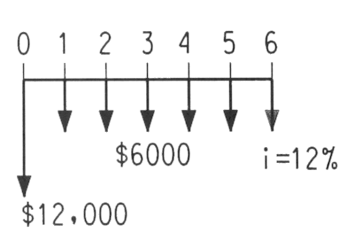  
Naive view**

If we didn't know any better we might think that the :

Average cost = (12000 + 6(6000) - 3000) / 6 = $7,500 / year

Hence the purchase looks advantageous when i = 0% or is not considered.  
This is not Correct.

Actually we know that the average cost is :

EAUC = $12,000(A/P,12,6) + $6,000 - $3,000(A/F,12,6)  
           = $8549 / year  
  
Thus, the equivalent cost of interest = $8549 - $7500 = $1049 / year  
Hence the current manual operation is economically more efficient when interest and capital recovery are considered.

**Capital Recovery (CR)**

The equivalent annual values of P and S are spread over N with i.  
  
Cost of capital recovery CR = P(A/P, i, N) - S(A/F, i, N)    
  
which translates to  CR = (P - S)(A/P, i, N) + Si

where Si is the annual amount of interest lost on future salvage cost and (P - S)(A/P, i, N) is the annual average amount of i weighted for cost of capital consumed.  
  
For our example: CR = (12,000 - 3,000)(A/P,12,6) + 3000(0.12)  
                                 = $2,549 / year (Interest weighted cost / year)

Average cost / year without interest = (12,000 - 3,000) / 6 = $1,500 / year

Difference = $2,549 - $1,500 = $1,049 = Average interest cost/year   
                                                             = Dollar cost/year for opportunities forgone  
                                                             = Cost of loss of use of money elsewhere.

Capital recovery can also be determined using the sinking fund equation where   
CR = (P-S) (A/F,i,N) + Pi.  
This equation will yield an identical result, but is sometimes used to determine the amount required to be saved to purchase a replacement in N years.

Thus any one of three equations can be used for finding CR:

CR = (P - S) (A/F, i ,N) + Pi

CR= (P - S) (A/P, i, N) + Si

CR = P(A/P, i, N) - S(A/F, i, N)

Example: A company buys a new machine for $10,000. It can be salvaged for $2,000 at the end of its 5 year life. How much money should be budgeted for replacement of the machine and compensation for lost interest of 6% ?

With Sinking fund :

CR = (10000 - 2000)(A/F,6,5) + 10000(6%)  
      = 8000(0.17740) + 10000(0.06)  
      = $2019.20 /year

With Capital recovery :

CR = (10000-2000)(A/P,6,5)+2000(6%)  
      = 8000(0.2374)+2000(0.06)  
      = $2019.20/year

**Economic service life**

How long should an asset be kept in service? The longer an asset is kept, the less the annual cost of capital recovery, but the higher the operation and maintenance cost.  
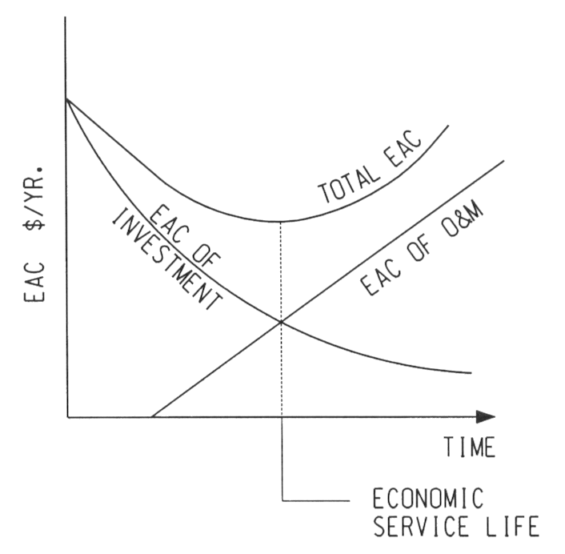The economic service life occurs at the minimum total EAC (The sum of CR and O&M).  
**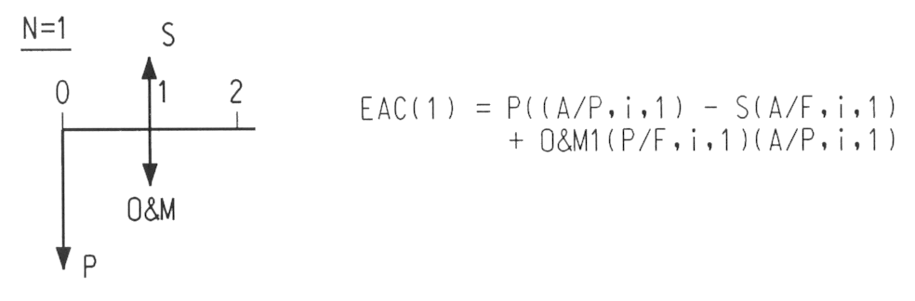  
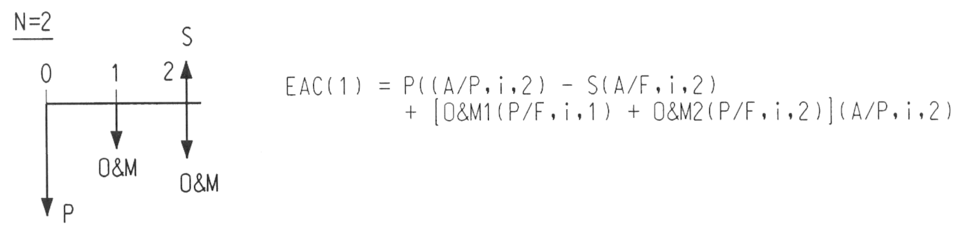**Thus, the EAC of ownership at any year j can be found by :

EACj = -P(A/P, i, j) - SV(A/F, i, j) + [(Sum from j =1 to Nof O&Mj)(P/F, i, j)](A/P, i, N)  
  
Example: Determine economic service life for i = 8%, equipment purchase price = $24,000, decline in salvage value = 20% / year, O&M cost = $3,000 for the first year, O&M increase = $1,000 /year.

   Life           Salvage Value                  Capital recovery        EAC          Total  
j, years              SVj               O&Mj            Cost                 O&M          EAC     
    1                $19,200        $3,000          $6720                $3000         $9720  
    2                $15,360         $4,000          $6074                $3481         $9555              
    3                $12,288         $5,000          $5528                $3949         $9477                    
   **4                $9,830           $6,000          $5065                $4404         $9469**  Least Cost           
    5                $7,864           $7,000          $4671                $4847         $9518               
    6                $6,291           $8,000          $4334                $5276         $9610

The minimum total EAC is in year 4. Thus, the equipment should be sold after year 4 yielding a  four year economic service life.

As an example, let's see how the year 4 EAC is calculated.

Capital Recovery cost = $24,000(A/P,8,4) - $9,830(A/F,8,4)   
                                  = $24,000(0.30192) - $9,830(0.22192)   
                                  = $5,065

EAC O&M (4) = [3000(P/F,8,1) + 4000(P/F,8,2) + 5000(P/F,8,3) + 6000(P/F,8,4)] (A/P,8,4)  
                        = [3000(0.9259) + 4000(0.8573) + 5000(0.7938) + 6000(0.7350)] (0.30192)  
                        = $4,404  
or in this case, since we have an arithmetic gradient

EAC O&M (4) = 3000 + 1000(A/G,10,4)  
                        = 3000 + 1000(1.4090)  
                        = $4,404

**UNIT 3 : BUDGETS**

**PART 1**

Understanding Budgeting

A budget is a microeconomic concept that shows the trade-off made when one good is exchanged for another. In terms of the bottom line—or the end result of this trade-off—a [surplus budget](https://www.investopedia.com/terms/b/budget-surplus.asp) means profits are anticipated, a [balanced budget](https://www.investopedia.com/terms/b/balanced-budget.asp) means revenues are expected to equal expenses, and a [deficit budget](https://www.investopedia.com/terms/b/budget-deficit.asp) means expenses will exceed revenues.

To manage your monthly expenses, prepare for life's unpredictable events, and be able to afford big-ticket items without going into debt, budgeting is important. Keeping track of how much you earn and spend doesn't have to be drudgery, doesn't require you to be good at math, and doesn't mean you can't buy the things you want. It just means that you'll know where your money goes, you'll have greater control over your finances.

KEY TAKEAWAYS

* A budget is an estimation of revenue and expenses over a specified future period of time and is utilized by governments, businesses, and individuals.
* A budget is basically a financial plan for a defined period, normally a year that is known to greatly enhance the success of any financial undertaking.
* Corporate budgets are essential for operating at peak efficiency.
* Aside from earmarking resources, a budget can also aid in setting goals, measuring outcomes, and planning for contingencies.
* Personal budgets are extremely useful in managing an individual's or family's finances over both the short and long term horizon.

Corporate Budgets

Budgets are an integral part of running any business efficiently and effectively.

Budget Development Process

The process begins by establishing assumptions for the upcoming budget period. These assumptions are related to projected sales trends, cost trends, and the overall economic outlook of the market, [industry,](https://www.investopedia.com/terms/i/industry.asp) or [sector](https://www.investopedia.com/terms/s/sector.asp). Specific factors affecting potential expenses are addressed and monitored.

The budget is published in a packet that outlines the standards and procedures used to develop it, including the assumptions about the markets, key relationships with vendors that provide discounts, and explanations of how certain calculations were made.

The sales budget is often the first to be developed, as subsequent expense budgets cannot be established without knowing future [cash flows](https://www.investopedia.com/terms/c/cashflow.asp). Budgets are developed for all the different subsidiaries, divisions, and departments within an organization. For a manufacturer, a separate budget is often developed for direct materials, labor, and overhead.

All budgets get rolled up into the master budget, which also includes budgeted [financial statements](https://www.investopedia.com/terms/f/financial-statements.asp), forecasts of cash inflows and outflows, and an overall financing plan. At a corporation, the top management reviews the budget and submits it for approval to the board of directors.

Static Vs. Flexible Budgets

There are two major types of budgets: [static budgets](https://www.investopedia.com/terms/s/staticbudget.asp) and flexible budgets. A static budget remains unchanged over the life of the budget. Regardless of changes that occur during the budgeting period, all accounts and figures originally calculated remain the same.

A flexible budget has a relational value to certain variables. The dollar amounts listed on a flexible budget change based on sales levels, production levels, or other external economic factors.

Both types of budgets are useful for management. A static budget evaluates the effectiveness of the original budgeting process, while a flexible budget provides deeper insight into business operations.

Personal Budgets

Individuals and families can have budgets, too. Creating and using a budget is not just for those who need to closely monitor their cash flows from month to month because "money is tight." Almost everyone—even people with large paychecks and plenty of money in the bank—can benefit from budgeting.

**PART 2**

Modern formal budgets not only limit expenditures; they also predict income, profits, and returns on investment a year ahead. They have evolved into tools of control and are also used as a means of determining such rewards as profit-sharing and bonuses. Unless the budgetary process is managed with extreme skill and care, the very virtues of budgeting can turn into negatives—and have, of late, emerged into a movement actively working to change this process.  
  
**BUDGETING AS A PROCESS**  
  
In large corporations, budgeting is a collective process in which operating units prepare their plans in conformity with corporate goals published by top management. Each unit plan is intended to contribute to the achievement of the corporate goals. Unit managers prepare projections of sales, operating costs, overhead costs, and capital requirements. They calculate operating profits and returns on the investment they intend to use. The budget itself is the projection of these values for the next calendar or fiscal year. As part of this process, each unit presents its plans and budget to a reviewing upper management panel and may, thereafter, make whatever changes result from instructions from or negotiations with the higher level. Texts presenting, documenting, and defending the rationales underlying the numbers are usually part of the planning document. Approved budgets then become the road-map for operations in the coming year. Ideally monthly or quarterly budget reviews track performance against the budget. As part of such reviews, changes to the budget may be approved. At year-end managers are judged by their performance against the budget.  
  
Many small businesses try to operate without a formal budget. Even some businesses that have a budget seldom consult it, meaning they are not gaining the business advantages that they could be through budgeting. For startup entrepreneurs, a budget is like a roadmap that can help them set goals and assess the validity of their business concept. For established small businesses, a budget can be used to take the pulse of the business, determining how the business is performing through the years, and helping identify possible future investments. By regularly consulting a budget, business leaders can compare actual figures and catch potential business shortfalls or other problems early. Budgets can also be instrumental in winning over investors, convincing banks your business is a good loan risk, or bringing on new partners or customers.  
  
While budgets are developed bottom up, managers must strive to meet top-down business goals (e.g., "Annual growth in after-tax profits of 39 percent."). Because performance is measured based on meeting or exceeding positive projections (of sales, returns, and profits) and meeting or coming in below negative projections (fixed and variable costs and capital expenditures) managers have strong incentives for projecting the lowest possible "positive" and the highest possible "negative" results. The more successful they are in understating sales and profits and overestimating costs, the higher the likelihood of "meeting the budget." Top management's incentives, by contrast, are to do the opposite. Therefore the budgeting process is inherently marked by potential conflict.  
  
Such difficulties can be, and usually are, mitigated by rational policies, good will on both sides, and straight forward implementation. Projections should be as realistic and quantifiable as possible. If projections are out of line with historical patterns, up or down, management must question the planning. Thus, for instance, a sharply rising projection of costs must have some real-world justification. Overly ambitious revenue projections must also be questioned. Conversely, managers must resist pressures sharply to raise revenue targets unless tangible changes in the market or compensating raises in sales expenditures are present. If the negotiating levels are honest and realistic, the right projections will result. Ideally, operating units should not be measured on activities over which they lack full control. An operation which does not operate its own debt collection, for example, should not be measured on how rapidly invoices are collected. Since budgets are often at least 50 percent guess-work, formal budgetary review at reasonable intervals and realistic adjustments based on actual events must be part of a well-functioning process. All too often, the spring budgeting event is rapidly forgotten.  
  
**BENEFITS AND COSTS**  
  
The single-most potential benefit of formal budgeting lies in ensuring that responsible managers take time each year (and then at fixed intervals throughout the year) in thinking about their operation by looking at all of its aspects. Budgeting creates a comprehensive picture of the future and makes both opportunities and barriers conscious. This foreknowledge then helps guide day-to-day activities.  
  
The chief cost of the budget process is time. In some corporations the process takes on a life of its own and becomes a convoluted exercise of excessive complexity which, moreover, prevents unit managers from doing any thinking: their time is consumed in efforts to comply with a vast array of requirements dictated from above. Much of the negative attitude that has developed concerning this activity has its roots in unnecessary bureaucratic impositions on the one hand and unreliability because of rapid change a few months out.

TYPES OF BUDGETS  
  
The two dominant forms of budgeting are traditional and zero-based. Business planning is usually a combination of the two. *Traditional*budgeting is based on a review of historical performance and then the projection of such findings to the future with modifications. If inflation is high, for instance, cost trends of the last several years are projected forward but with adjustments both for inflation and for projected growth or decline in business activity. Historical sales patterns, using established trends in sales growth, are projected; new sales from planned new product introductions are then added. *Zero-based* budgeting is the creation of a completely new budget from the ground up—as if no history existed. When using this method, the operation must justify and document every item of expenditure and income anew. Brand-new operations will utilize zero-based methods.

In government planning, but only very rarely in business, performance budgeting is used as a third alternative. Under this method, the budget is fixed at the outset. The planning activity is to determine exactly what activities will be carried out using the allocated funds. *Performance*budgeting is sometimes used in the corporate setting when the advertising budget is arbitrarily set as such-and-such a percent to projected sales. The advertising function then uses performance budgeting to allocate the budget to various products and media.  
  
For the small business, different types of budgets can be drafted to monitor various financial aspects of the business.  
  
• **Operational budget** - An operational budget is the most common type of budget used. It forecasts and tries to pretty closely predict yearly revenue and expenses for a business. This budget can be updated with actual figures on a monthly basis and then you can revise your figures for the year, if needed.  
  
• **Cash flow budget**- A cash flow budget details the amount of cash you collect and pay out. This is generally tallied on a monthly basis, but some businesses tabulate this weekly. In this budget, you track your sales and other receivables from income sources and contrast those against how much you pay to suppliers and in expenses. A positive cash flow is essential to grow your business.  
  
• **Capital budget** - The capital budget helps you figure out how much money you need to put in place new equipment or procedures to launch new products or increase production or services. This budget estimates the value of capital purchases you need for your business to grow and increase revenues.

**PART 3**

## Four Main Types of Budgets/Budgeting Methods

There are four common types of budgets that companies use: (1) incremental, (2) activity-based, (3) value proposition, and (4) zero-based. These four budgeting methods each have their own advantages and challenges, which will be discussed in more detail in this guide.

[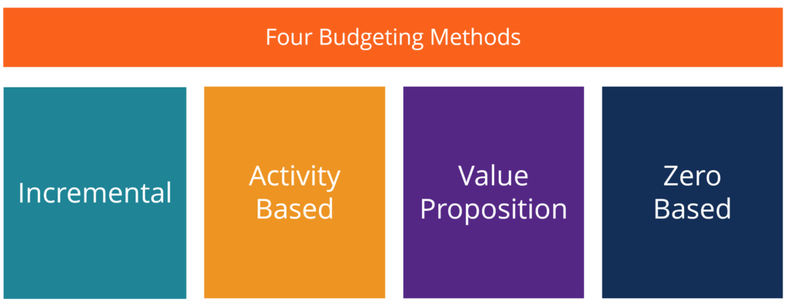](https://courses.corporatefinanceinstitute.com/courses/budgeting-and-forecasting-fpa)

Source: CFI’s [Budgeting & Forecasting Course](https://courses.corporatefinanceinstitute.com/courses/budgeting-and-forecasting-fpa).

#### 1. Incremental budgeting

Incremental budgeting takes last year’s actual figures and adds or subtracts a percentage to obtain the current year’s budget.  It is the most common method of budgeting because it is simple and easy to understand.  Incremental budgeting is appropriate to use if the primary [cost drivers](https://corporatefinanceinstitute.com/resources/knowledge/accounting/cost-driver/) do not change from year to year.  However, there are some problems with using the method:

* It is likely to perpetuate inefficiencies. For example, if a manager knows that there is an opportunity to grow his budget by 10% every year, he will simply take that opportunity to attain a bigger budget, while not putting effort into seeking ways to cut costs or economize.
* It is likely to result in budgetary slack. For example, a manager might overstate the size of the budget that the team actually needs so it appears that the team is always under budget.
* It is also likely to ignore external drivers of activity and performance. For example, there is very high [inflation](https://en.wikipedia.org/wiki/Inflation) in certain input costs.  Incremental budgeting ignores any external factors and simply assumes the cost will grow by, for example, 10% this year.

#### 2. Activity-based budgeting

Activity-based budgeting is a [top-down budgeting](https://corporatefinanceinstitute.com/resources/knowledge/finance/top-down-budgeting/) approach that determines the amount of inputs required to support the targets or outputs set by the company.  For example, a company sets an output target of $100 million in revenues.  The company will need to first determine the activities that need to be undertaken to meet the sales target, and then find out the costs of carrying out these activities.

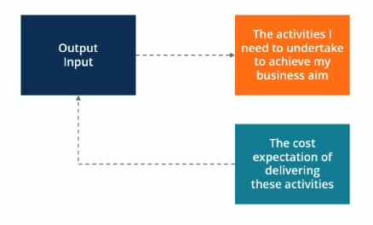

Source: CFI’s [Budgeting & Forecasting Course](https://courses.corporatefinanceinstitute.com/courses/budgeting-and-forecasting-fpa).

#### 3. Value proposition budgeting

In value proposition budgeting, the budgeter considers the following questions:

* Why is this amount included in the budget?
* Does the item create value for customers, staff, or other stakeholders?
* Does the value of the item outweigh its cost? If not, then is there another reason why the cost is justified?

Value proposition budgeting is really a mindset about making sure that everything that is included in the budget delivers value for the business. Value proposition budgeting aims to avoid unnecessary expenditures – although it is not as precisely aimed at that goal as our final budgeting option, zero-based budgeting.

#### 4. Zero-based budgeting

As one of the most commonly used budgeting methods, [zero-based budgeting](https://corporatefinanceinstitute.com/resources/knowledge/accounting/zero-based-budgeting/) starts with the assumption that all department budgets are zero and must be rebuilt from scratch.  Managers must be able to justify every single expense. No expenditures are automatically “okayed”. Zero-based budgeting is very tight, aiming to avoid any and all expenditures that are not considered absolutely essential to the company’s successful (profitable) operation. This kind of bottom-up budgeting can be a highly effective way to “shake things up”.

The zero-based approach is good to use when there is an urgent need for cost containment, for example, in a situation where a company is going through a financial restructuring or a major economic or market downturn that requires it to reduce the budget dramatically.

Zero-based budgeting is best suited for addressing discretionary costs rather than essential operating costs. However, it can be an extremely time-consuming approach, so many companies only use this approach occasionally.

### Levels of Involvement in Budgeting Process

We want buy-in and acceptance from the entire organization in the budgeting process, but we also want a well-defined budget and one that is not manipulated by people.  There is always a trade-off between goal congruence and involvement. The three themes outlined below need to be taken into consideration with all types of budgets.

#### Imposed budgeting

Imposed budgeting is a top-down process where executives adhere to a goal that they set for the company.  Managers follow the goals and impose budget targets for activities and costs.  It can be effective if a company is in a turnaround situation where they need to meet some difficult goals, but there might be very little goal congruence.

#### Negotiated budgeting

Negotiated budgeting is a combination of both top-down and bottom-up budgeting methods.  Executives may outline some of the targets they would like to hit, but at the same time, there is shared responsibility for budget preparation between managers and employees. This increased involvement in the budgeting process by lower-level employees may make it easier to adhere to budget targets, as the employees feel like they have a more personal interest in the success of the budget plan.

#### Participative budgeting

Participative budgeting is a roll-up approach where employees work from the bottom up to recommend targets to the executives.  The executives may provide some input, but they more or less take the recommendations as given by department managers and other employees (within reason, of course).  Operations are treated as autonomous subsidiaries and are given a lot of freedom to set up the budget.

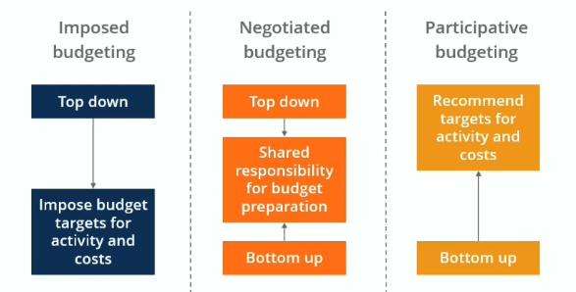

**UNIT 4: NEW PRODUCT FAILURES**

**PART 1**

Marketers know that they’ve got to keep a steady stream of new products and/or services flowing—if for no other reason than to keep up with the competition. As circumstances, needs, wants, and trends change, no one wants to get left behind. At the same time though, marketers also know that innovation these days is pretty risky business.

In Winning at New Products, author Robert Cooper estimates that about half of all resources allocated to “product development and commercialization” in the U.S. goes to products that a firm cancels or produce an inadequate financial return. In packaged goods, for instance, IRI calculated that less than a quarter of the new products introduced in 2008 broke the $7.5 million in sales mark their first year of availability and less than one-half of 1% earned more than $100 million in sales. Though estimates of new product and service failure rates vary widely by company, category, industry, and reporting agency, the best-case-scenario chances of introducing a successful new product or service don’t get much better than 50-50.

Through our own work with companies across different industries, we found about 10%-20% of new products and services succeed, which by our definition means they remain in the market generating profits for the company three years after introduction.

Why has success proven so elusive to so many?

Here’s our top 10 list of reasons new products and services fail:

1. Marketers assess the marketing climate inadequately.
2. The wrong group was targeted.
3. A weak positioning strategy was used.
4. A less-than-optimal "configuration" of attributes and benefits was selected.
5. A questionable pricing strategy was implemented.
6. The ad campaign generated an insufficient level of awareness.
7. Cannibalization depressed corporate profits.
8. Over-optimism about the marketing plan led to a unrealistic forecast.
9. Poor implementation of the marketing plan in the real world.
10. The new product was pronounced dead and buried too soon.

**PART 2**

## Why new products fail

### No product point-of-difference

For a new product to win initial trials and then ongoing repeat business, it needs to bring something new to the marketplace. Potential customers need an incentive – such as additional benefits or some form of variety – to be persuaded to try and buy a new product. Without any real [point of difference](http://www.segmentationstudyguide.com/understanding-perceptual-maps/points-of-difference-pod/), the new product is likely to fail.

### Limited retailer support

Most retailers are pretty happy with their existing merchandising mix and also need to be persuaded that the new product has value for them and their customers. Many new products will fail because they do not obtain the necessary distribution and market coverage to be viable, due to lack of interest from most retailers.

### Poor product design

Virtually all products that are put to development and launch sound good on paper. However, during the development phase when final design decisions are made at the product is actually developed and produced, this may not go exactly to plan. The end result is a poorly designed or poor quality product, which is unlikely to generate a large number of repeat sales.

### Established customer loyalty in the market

The success of new products will rely upon existing consumers being willing to switch from their current purchases OR entering a market where there are a significant proportion of first-time customers without any established brand loyalty. In many cases, existing customer inertia – the unwillingness to switch brands – will limit the potential success of a new product. Clearly this phenomenon will vary by type of product – for example, many basic supermarket products are bought by consumers who follow simple habitual loyalty and are less likely to switch as a result.

### Weak launch or poorly executed launch

Most new products require a reasonable degree of promotional support to build brand awareness and to access distribution channels and retailers. With a limited launch budget or a poorly executed launch, then the success of a new product is less likely.

### Adverse media attention

Occasionally a new product may attract adverse media attention, usually related to deficiencies in the product design, price level, or early use problems experienced by consumers. If this occurs, in today’s Internet connected world it becomes difficult to achieve new product success.

### Aggressive competitor actions

Virtually all new products are designed to take market share away from established competitors. Therefore, some form of competitor reaction should be expected. In some cases competitors will increase their level of promotion, reduced prices, leverage retail relationships to discourage their partners from supporting a new product from a competitor, or even launch a similar product themselves.

All of these initiatives are designed to protect their market share and try to have the new product to be as unsuccessful as possible.

### Poor pricing or cost structure

New products may suffer from a poor pricing and cost structure. Sometimes companies will design products with many features in an attempt to bring something new to the market. As a result, these products are often more costly to produce, but the firm expects the marketplace to have a willingness to pay more for a better product. This may or may not be the case and this product strategy may be quite successful, or be perceived as poor value in the market.

In line with this concern, an expensive development process, along with an expensive launch, may necessitate the need to charge a higher price – which again may or may not be accepted by the marketplace.

### Weak supporting brand equity

As we know, new products launched under a strong brand have a greater likelihood of success. This is because the brand has existing customer following and loyalty. These consumers are more likely to trial the new products produced by a brand that they trust and like. Obviously the reverse will apply – weak brands do not have the same degree of customer loyalty or brand awareness, and are therefore less likely to generate strong sales due to their brand support.

### Small target market

In today’s marketing world, market segments are fragmenting and a number of companies now pursue [niche markets](http://www.segmentationstudyguide.com/understanding-target-markets/niche-marketing/). While niche markets provide a suitable and possibly attractive market if there is no or little competition, they have the danger of being relatively small. Clearly a small target market will generate less sales volume and is less financially viable as a consequence.

### No clear market need or perceived product benefits

For [new-to-the-world products](https://www.marketingstudyguide.com/new-world-products/), they have the extra concern of whether their benefits/features are actually meeting a market need. By their very nature, this classification of new products (brand-new inventions) are something new to the marketplace and provide a different solution to an established need and sometimes a solution to need it does not yet exist in the minds of the consumer.

Therefore, if the company misreads this situation, then their level of sales is likely to be disappointing. This is relatively common with backyard inventors who think that their new invention is the next big thing.

### Poor internal marketing

[Service companies](https://www.marketingstudyguide.com/service-firm-examples/) in particular rely on internal staff – such as retail staff and call center staff and various other customer contact personnel. Usually they are the sales or fulfillment part of the overall launch and marketing process of the new product. Surprisingly, without an internal marketing program to convince the staff members of the benefits of the new product for their customers, many of them will be reluctant to sell, or help switch customers to, the new product.

### Existing product cannibalization

A risk associated with a [product line extension](https://www.marketingstudyguide.com/product-line-extension/) is that it may simply cannibalize an existing product. So in essence, while the new product may be successful, because it could take significant sales away from an established product the overall new product could be deemed a failure by management. This is because the company has invested time and money into bringing new product to market, yet no additional profitability has been delivered to the bottom line.

However, of course, there are companies who believe in the importance of cannibalizing their own products – primarily as a competitive defensive measure – an example here is [3M](https://www.marketingstudyguide.com/example-swot-3m/).

### Weak sales for size of company

When we discuss a product failure, it needs to be considered in conjunction with the overall size of company. For example, take a large company like Coca-Cola. If they were to bring a new product to market, some sort of beverage, and that only generated $1 million per year profit (which is good money for the average company) a company the size of Coca-Cola would deem this new product a failure and would probably look to discontinue it.

### Insufficient time for success

Because new product success relies upon consumers being willing to switch and trial new products and then become a repeat and loyal purchaser, there are several steps phases involved in the customer’s journey. This process obviously takes time. Some companies are willing to wait and invest in a new product, whereas others seek and expect almost instant success in the marketplace.

**UNIT 5 : LEADERSHIP**

**PART 1**

**Leadership** in business is the capacity of a company's **management** to set and achieve challenging goals, take fast and decisive action when needed, outperform the competition, and inspire others to perform at the highest level they can.

| Skills Good Leaders Need.  Strategic Thinking. Planning and Delivery. People Management. Change Management.  Communication. Persuasion and Influence. | | |
| --- | --- | --- |
| **Leadership** | **Management** |
| May or may not be a manager | May or may not be a leader |
| Must inspire followers | May or may not inspire those under them |
| Emphasizes innovation | Emphasizes rationality and control |
| May be unconcerned with preserving existing structures | Seeks to work within and preserve existing corporate structures |
| Typically operates with relative independence | Typically a link in the corporate chain of command |
| May be less concerned with interpersonal issues | May be more concerned with interpersonal issues |

**UNIT 6 : SUBCONTRACT MANAGEMENT**

**PART 1**

Subcontract management is a critical part of the contract lifecycle. What’s the big deal?

When a contract is created between a buyer and seller, it’s common for the seller (the prime contractor) to obtain the required supplies or services from other companies (subcontractors) in order to fulfill the contract. This is where subcontract management comes in.

WHAT IS SUBCONTRACT MANAGEMENT?

Subcontract management is in the post-award life cycle phase of contract management, and it is in the “Perform Contract” domain. It is the contract management of subcontracts, with the prime contractor being responsible for the performance of its supply chain. The value added by this process is in having a single point of contact responsible for:

* Subcontract award,
* Technical and financial performance,
* Monitoring performance, and
* Payment to the subcontractors and suppliers for the work accomplished under subcontract terms.

**PART 2**

Subcontractor management is a process that involves overseeing the lifecycle of one or more subcontracts for an employer.

The subcontract management process involves:

* Identifying the employer’s specific needs for a project
* Identifying and qualifying potential contractors
* Communicating employer policies to hired subcontractors
* Providing ongoing oversight of contracts

Subcontractor managers are responsible for enforcing the safety and cost provisions of a given contract and for determining if any request to deviate from those provisions by a subcontractor can be reasonably justified.

It is also called subcontractor administration.

Subcontractor management ensures consistency in how a firm manages its subcontractors, which in turn mitigates the risk to the employer.

Consistency is achieved by defining, to the greatest extent reasonably practicable, a uniform framework of expectation for both all subcontracted and all project management personnel.

Creating a managed, uniform framework for communication between the employer and subcontractor prevents projects with numerous subcontractors from becoming fragmented or inflexible. By eliminating these challenges, the communication framework reduces the likelihood that subcontractors will engage in non-compliant behavior.

**Four Phases of Subcontractor Management**

The subcontractor management process can be roughly divided into four distinct phases:

1. **The pre-award phase** centers primarily upon identifying the needs of a project and locating individuals capable of delivering those needs
2. **The award phase** involves qualifying and procuring the actual contract, along with establishing basic criteria for project work, such as safety standards
3. **The post-award phase** centers around monitoring compliance by subcontractors and maintaining ongoing communication
4. **The close-out phase** focuses on validating that all agreed-upon responsibilities have been adequately delivered by the hired subcontractor.

**Subcontractor Managers**

Subcontractor managers (SCMs) oversee the procurement of the material, equipment, and service contracts by the employer for the purpose of successfully completing a project that the employer has either initiated itself or has been contracted to perform.

SCMs commonly hold professional certificates in related fields, such as the Institute for Supply Management’s Certified Professional in Supply Management (CPSM) designation and the Certified Professional Contracts Manager (CPCM) designation from the National Contracts Management Association.